Lawyer

website

“LAW NETWORK”

**PROJECT:** Lawyer website

**Group Members:-**

|  |  |
| --- | --- |
| **GROUP MEMBERS** | **ENROLMENT NO.** |
| Asma Atique | STUDENT1353632 |
| Mahnooor Tariq | STUDENT1349179 |

**FACULTY :** HAFSA KHAN

**BATCH CODE :** 2111G2

**CURRICULUM :** 7062

**SEMESTER :** DISM



CHAPTER: 01

HOME PAGE

This is the User Home Page.

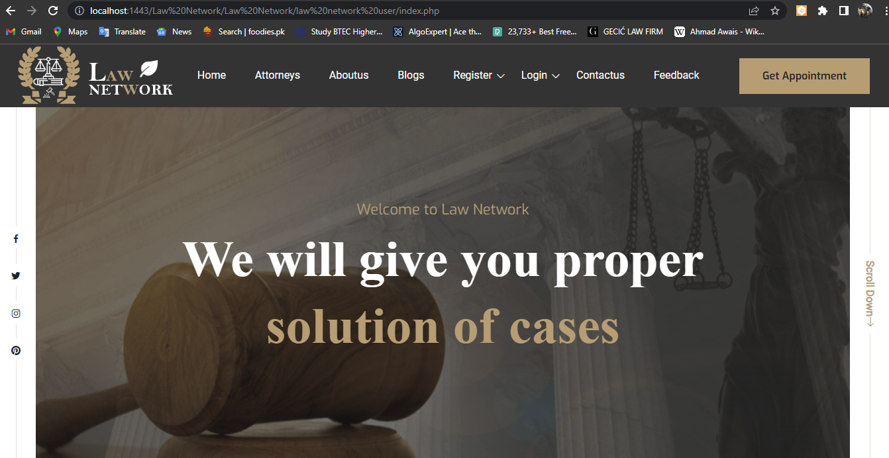

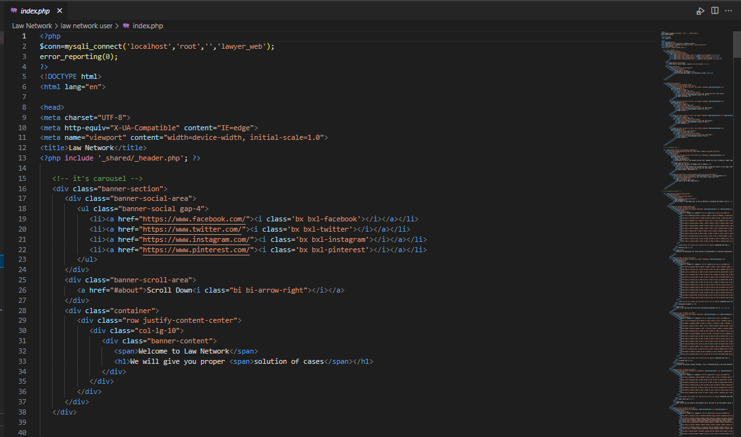



CHAPTER: 02

ABOUT US

This is the About Us Page

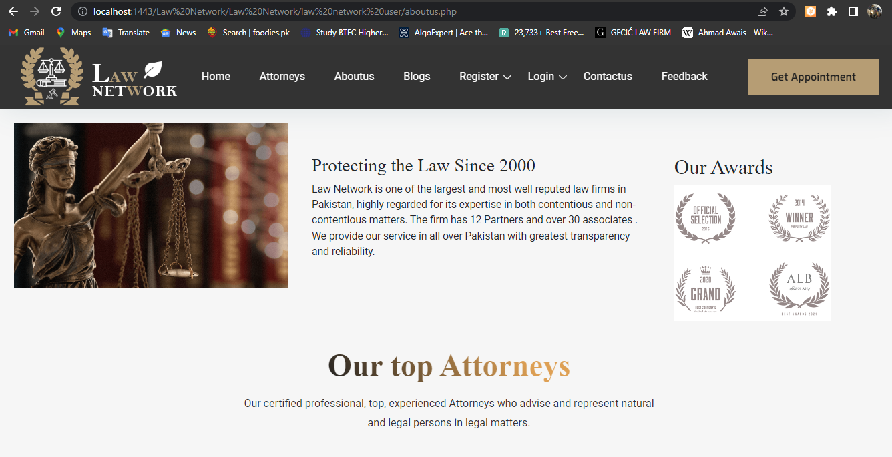

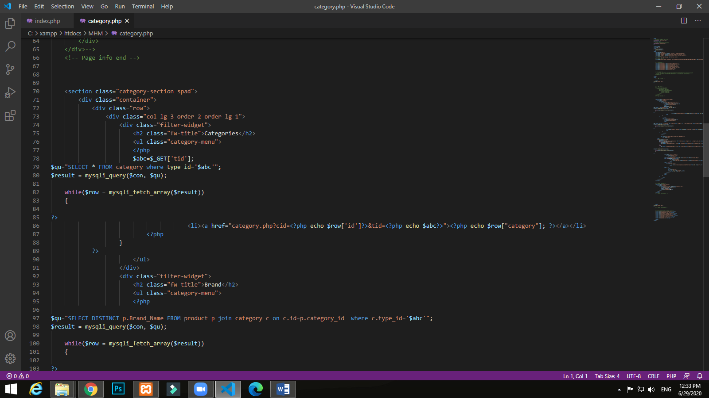



CHAPTER: 03

CONTACT US

This is the Contact us Page.

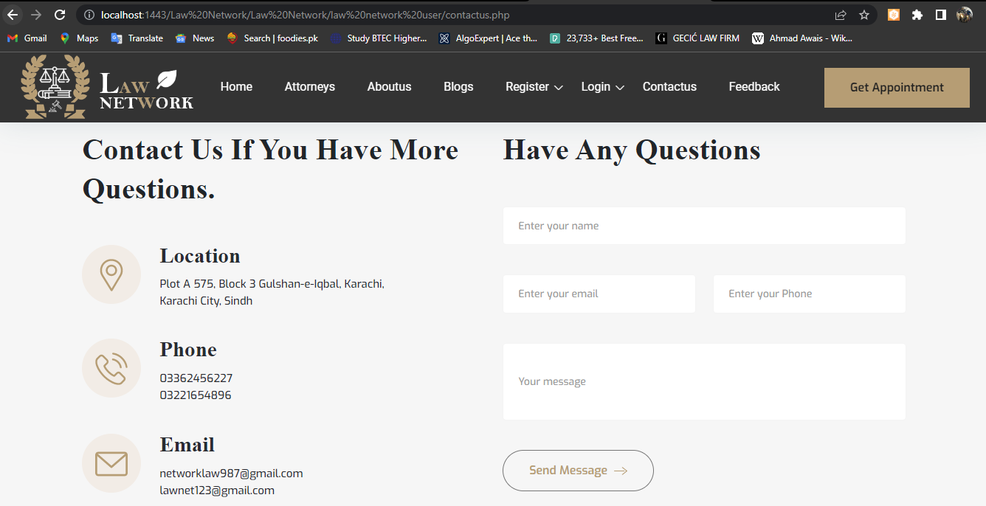

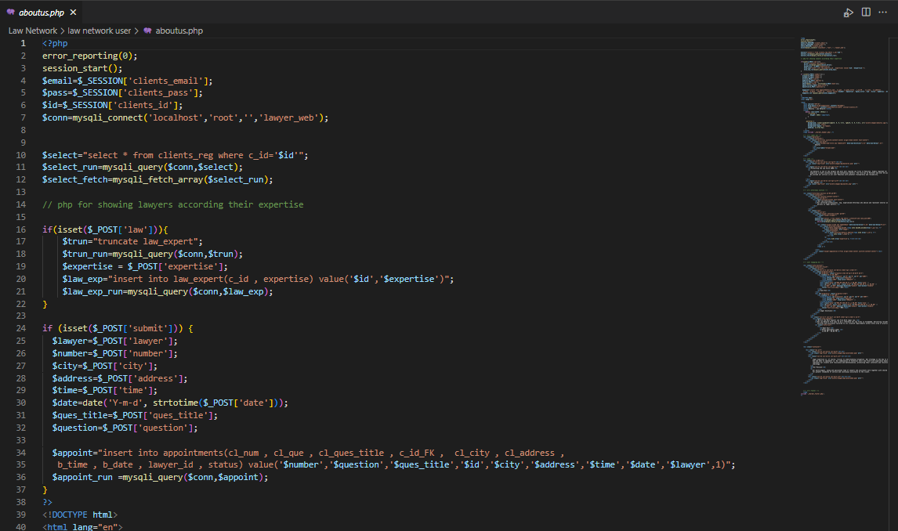



CHAPTER: 04

SIGNUP

## 

This is where you SignUp as a user.

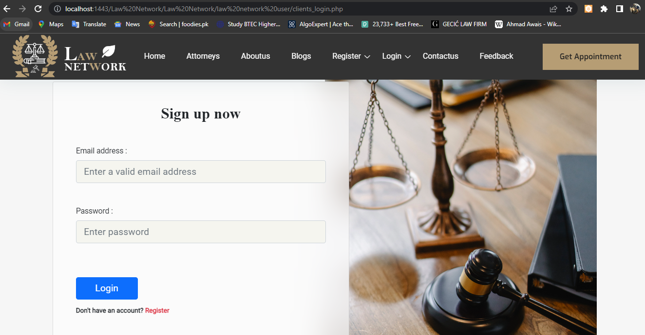

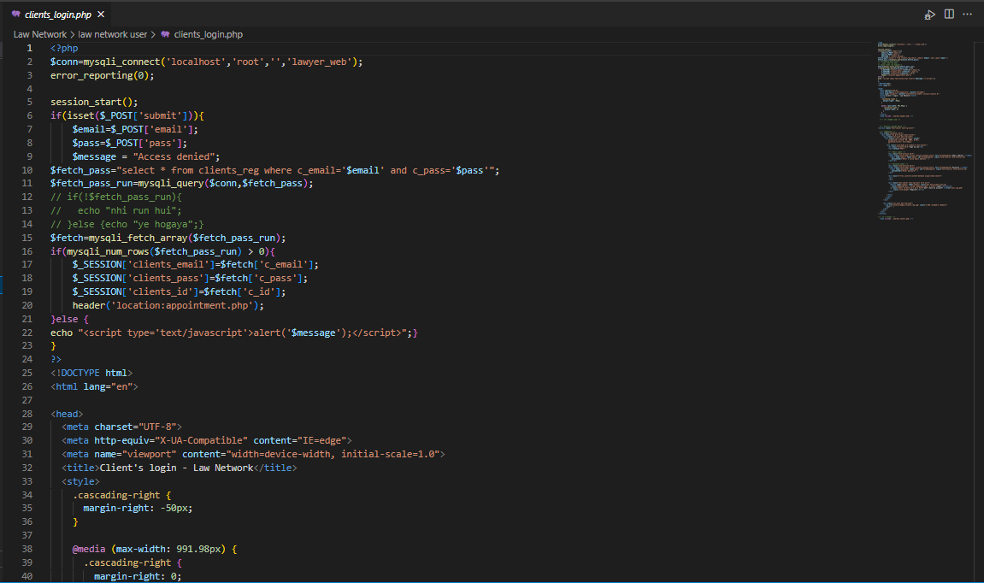



CHAPTER: 05

USER LOGIN

After Signup you will go to Userlogin where you login than book your case.



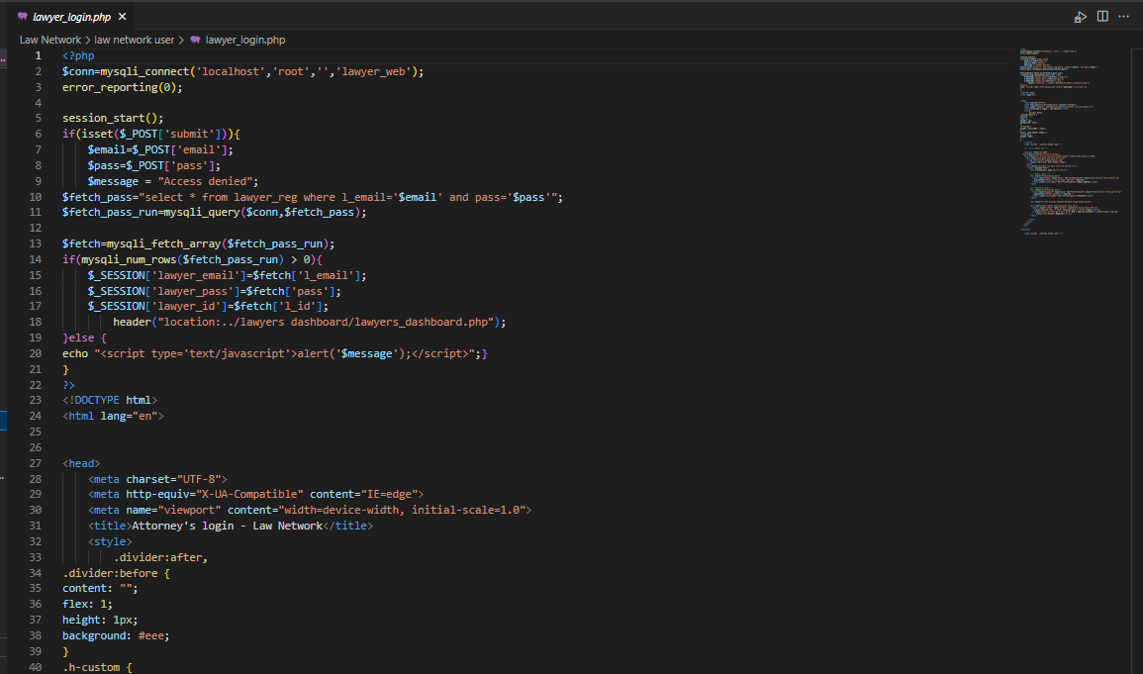



.

CHAPTER: 06

APPOINTMENT

This is the appointment Pages.

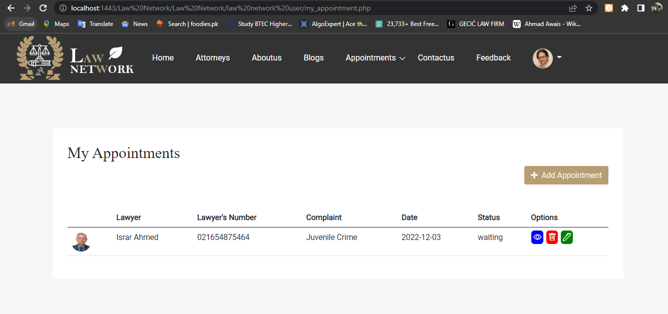

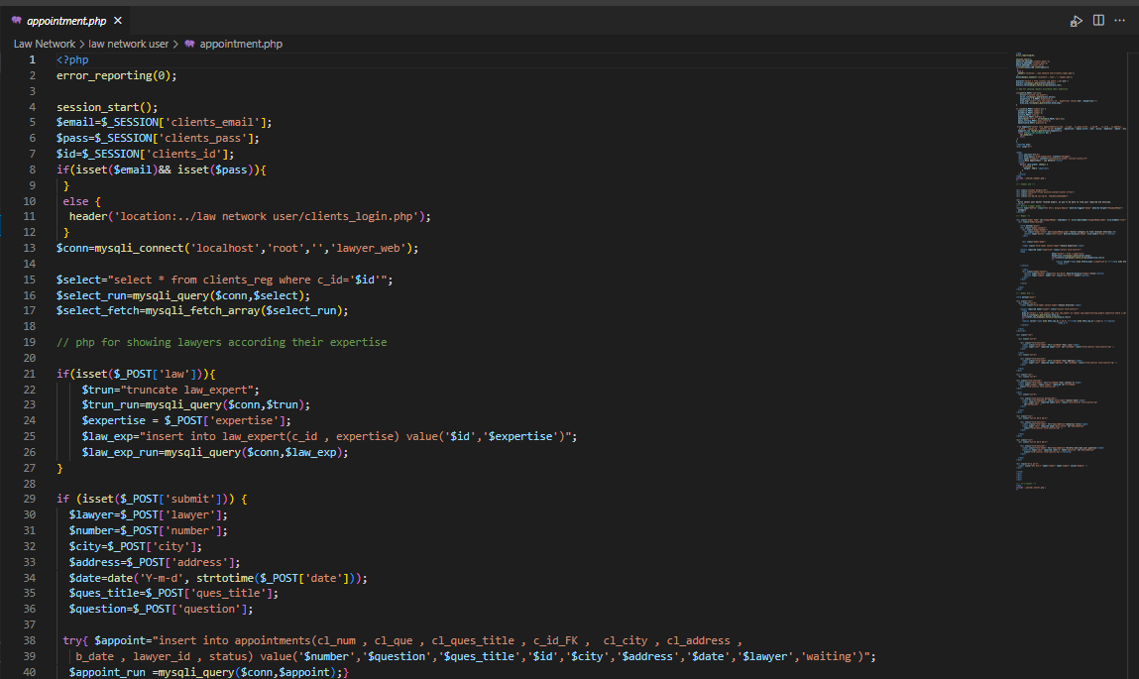

 CHAPTER: 07

DASHBOARD

This the Admin Login where the admin go into the Dashboard.

